AngularJS Webpack ES6

Compiling Process on Windows

# Requirements

1. NodeJS - package manage

2. Compass server – written in Ruby and required to compile SASS  
3. Git – required for dependencies installing

4. Project source code

# Windows Command Prompt

We can use Window Command Prompt to execute commands.

# Installing NodeJS on Windows

1. Download the Windows installer at <https://nodejs.org/en/download/>, please select version **6.11.4 LTS**, the current stable version of NodeJS.  
  
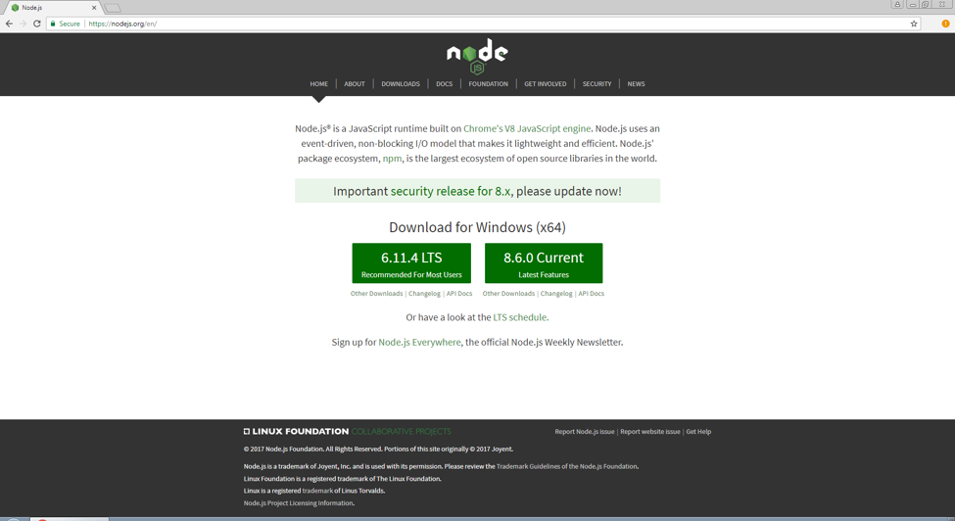

2. Run the installer (the .msi file.)  
  
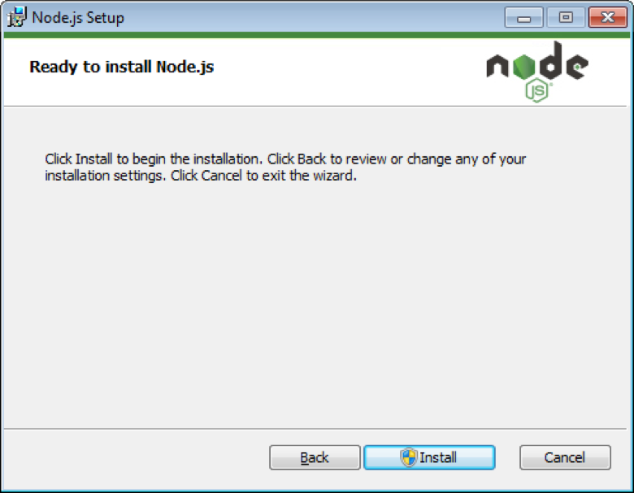

3. Follow the prompts in the installer and finish.

4. Restart your computer.

# Test Node and NPM

1. Run ’**node -v**’ to get the current version of NodeJS in your computer and ’**npm -v**’ to get the current version of NPM in your computer.  
  
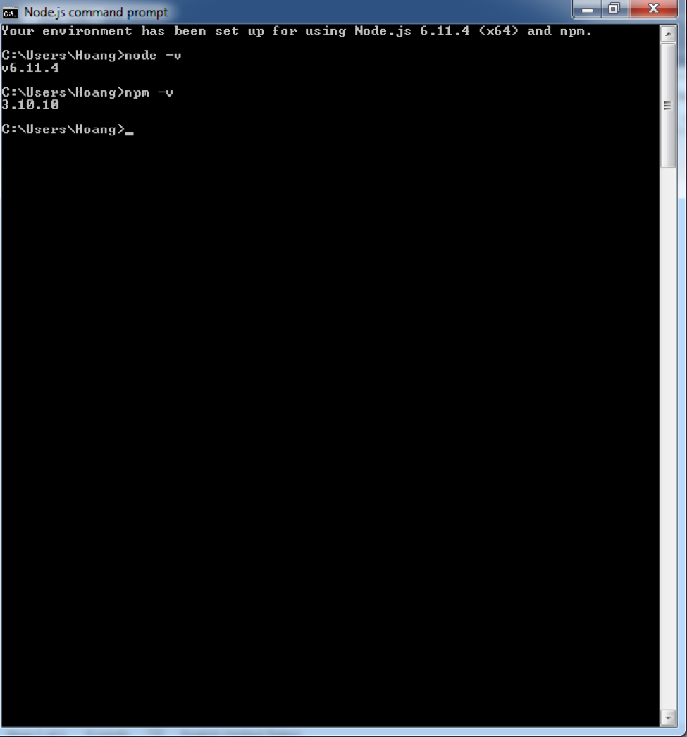

# Installing Ruby for Windows and Compass Server

1. Download Ruby installer for Windows at <https://rubyinstaller.org/downloads/>, you should be able to download version **2.4.X**  
  
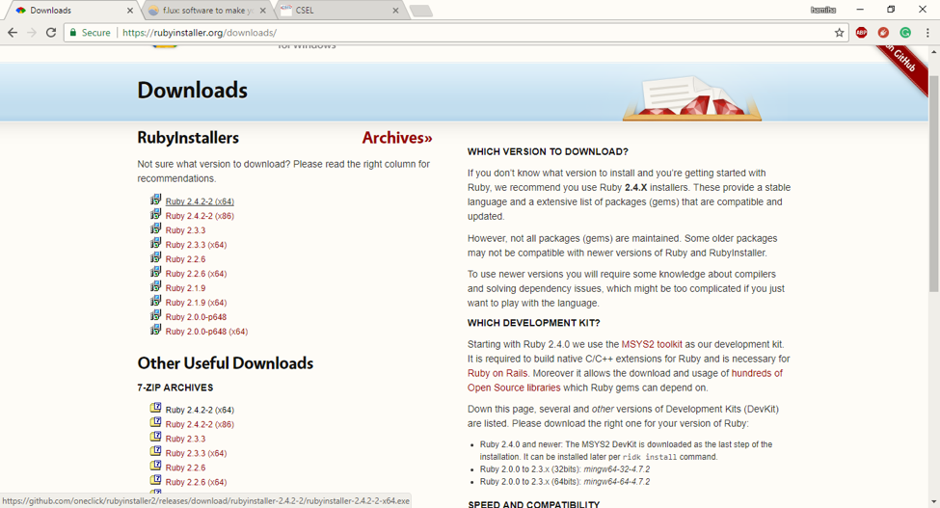

2. Installing Ruby  
  
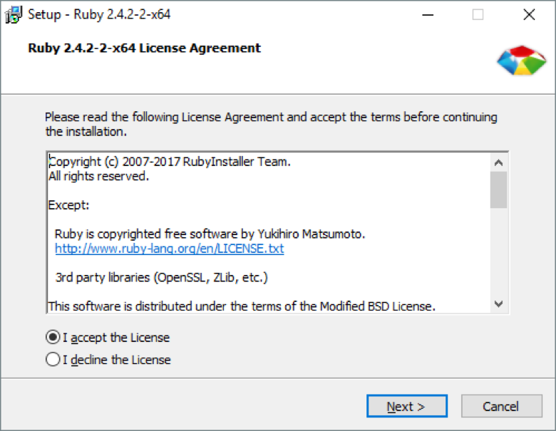

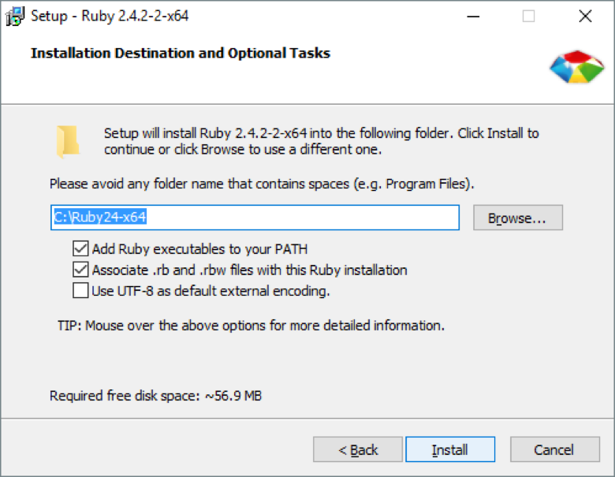

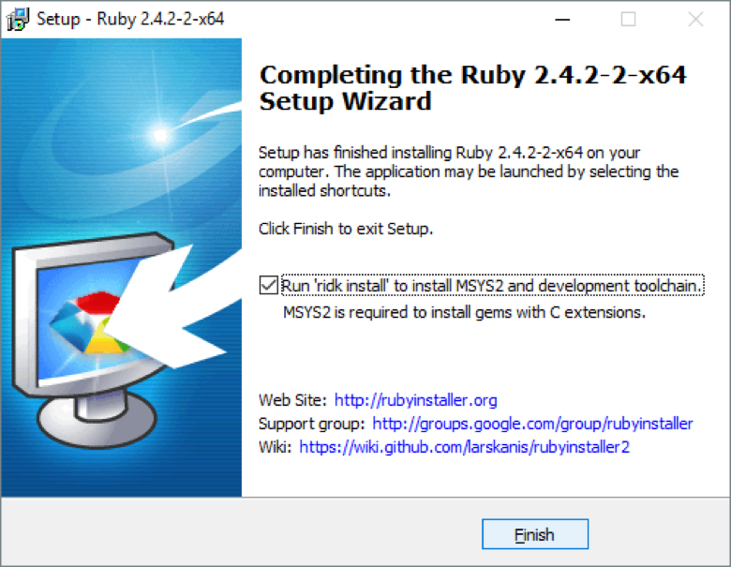

3. After finishing installing Ruby, you will be asked to install MSYS2, a required extension for Ruby to build C language.

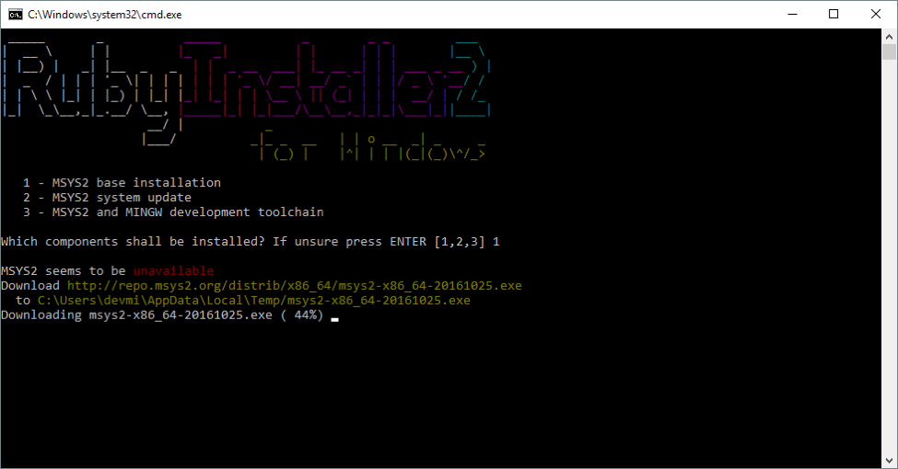

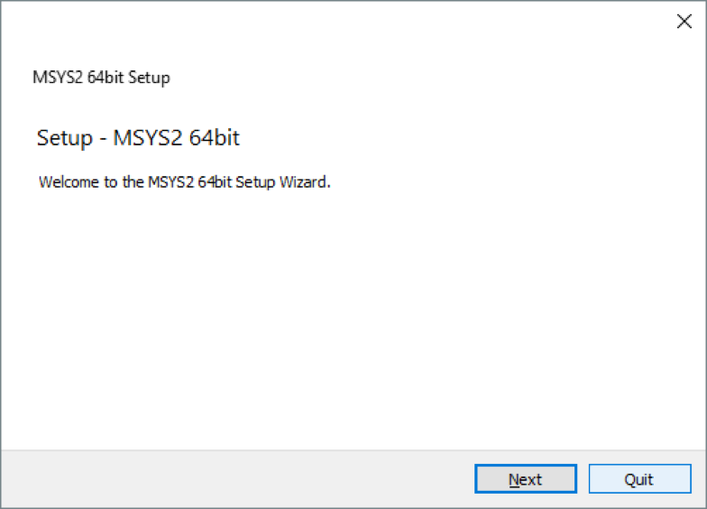

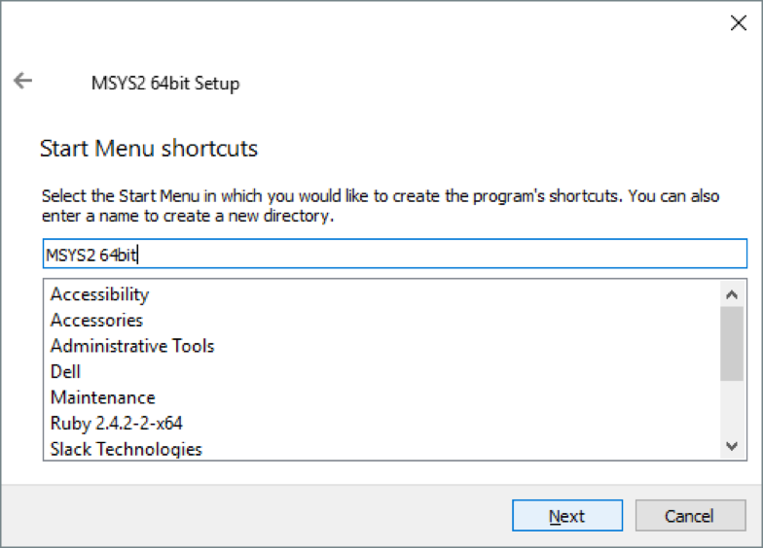

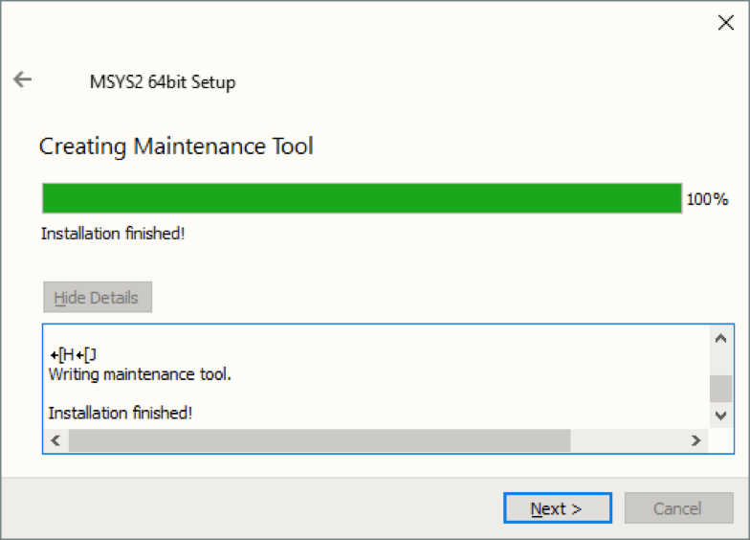

4. Restart Command Prompt app, check by running ‘**ruby -v**’.

5. Installing Compass server by running ‘**gem install compass**’.

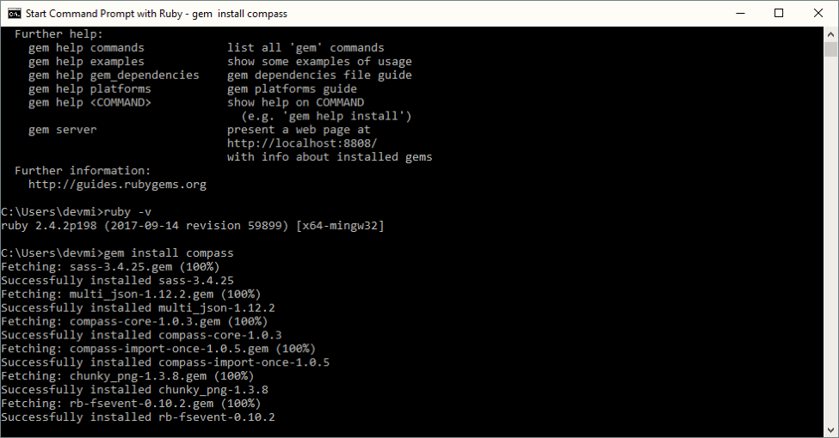

# Installing Git SCM for Windows

1. Download Git SCM for Windows at <https://git-scm.com/download/win>, it will automatically download the installer

2. Run the installer, you should leave the default setting  
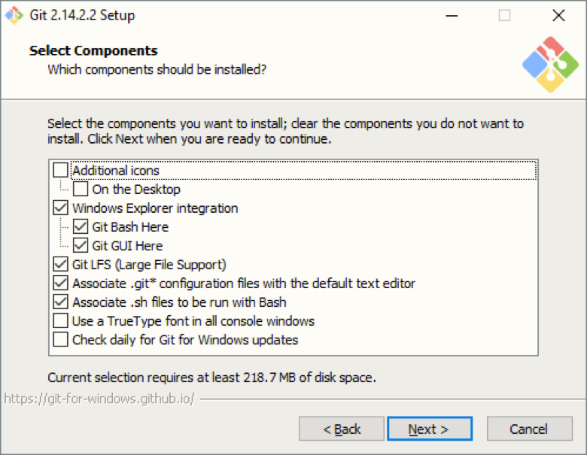

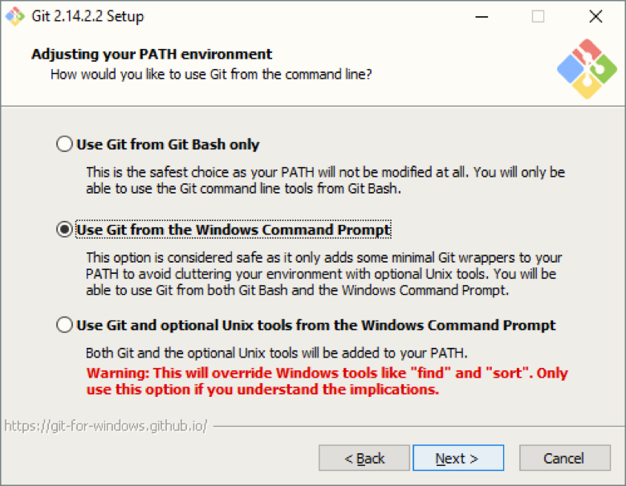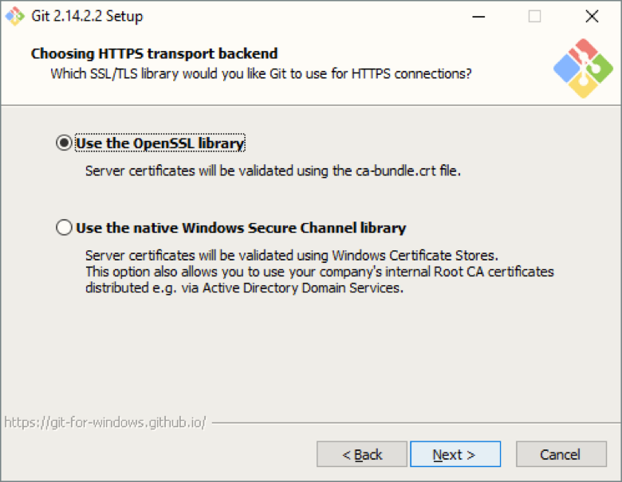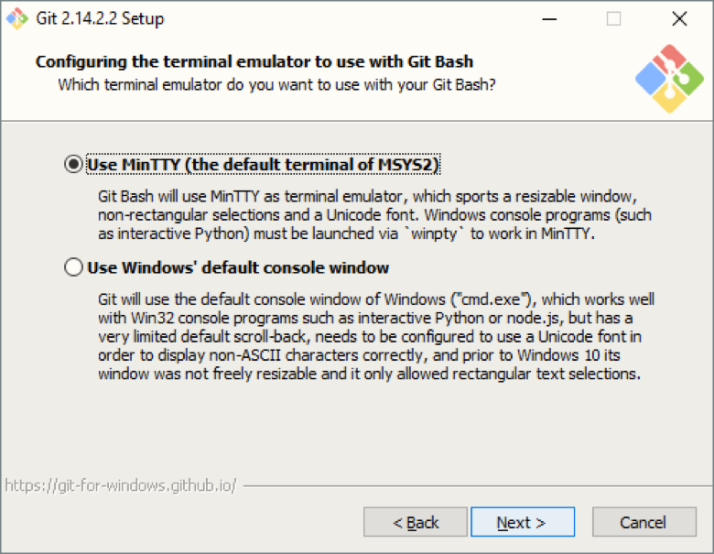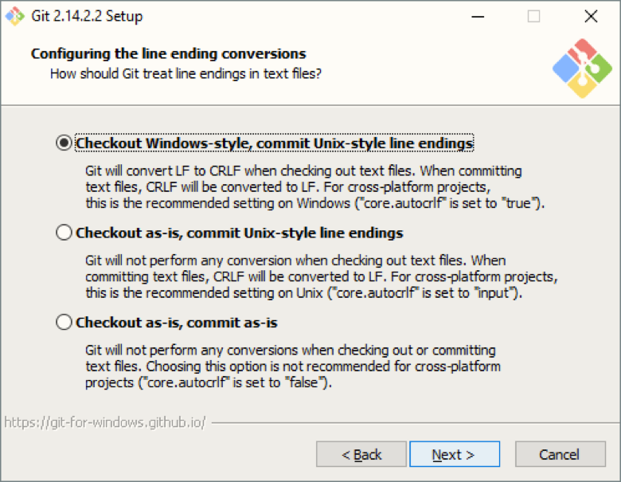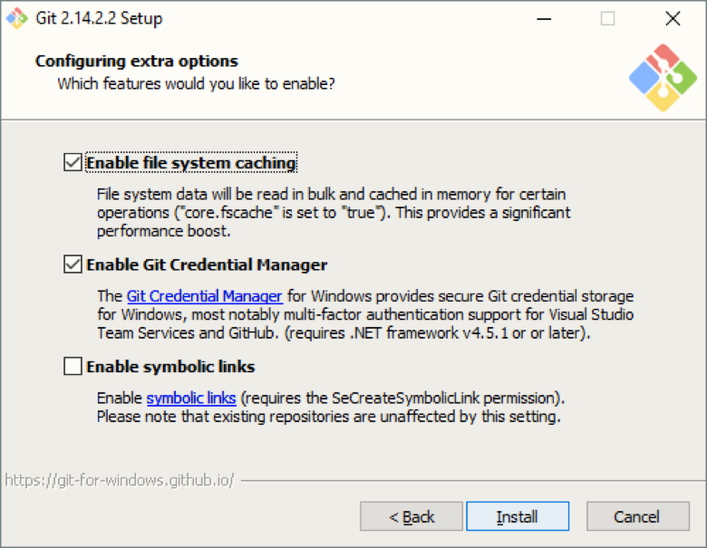

# Now we should have all the required software to compile project

Running ‘**npm install –g yarn webpack**’ to install Yarn and Webpack globally.

1. Open the project source code folder under command line windows.

2. Run ‘**npm install**’ (all dependencies will be installed under **node_modules** folder), you can also run ‘**yarn**’ or ‘**yarn install**’, they both do the same job.

3. To run project locally to test, please run ‘**npm start**’ or ‘**yarn start**’, and the project should be available at <localhost:8080/>

# URL Configuration for Sub-Path Domain Deployment

Usually, if you deploy to base URL (e.g. <http://www.cis.umassd.edu/)>, you don’t need to configure these setting. However, if you plan to deploy to a sub-path (<http://www.cis.umassd.edu/~dluong1/csel-new/)>, you need to make changes to 3 files:

**1. index.html**

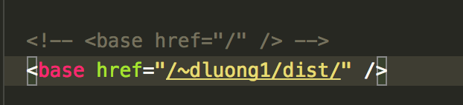

Inside <head> tag, you will find the <base> tag with attribute href, change this attribute’s value match your current sub-path (the part after main domain), for example, in this case the sub-path is /~dluong1/dist/. UI-Router module of AngularJS uses this tag to determine the base URL of your website, usually it will take the main domain, but if you deploy to sub-path, you need to make change to this tag. This file is in the **src/public** folder.

**2. .htaccess**

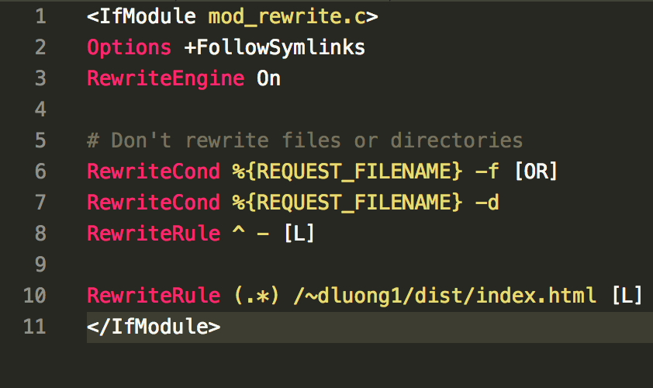

In the **src/public** folder, you will find the .htaccess file, change the **RewriteRule** value to match your current sub-path (the last line). Note that the .htaccess is only working when mode_rewrite of Apache server is turned on, read more at [this article](https://stackoverflow.com/questions/869092/how-to-enable-mod-rewrite-for-apache-2-2).

**3. webpack.config.js**

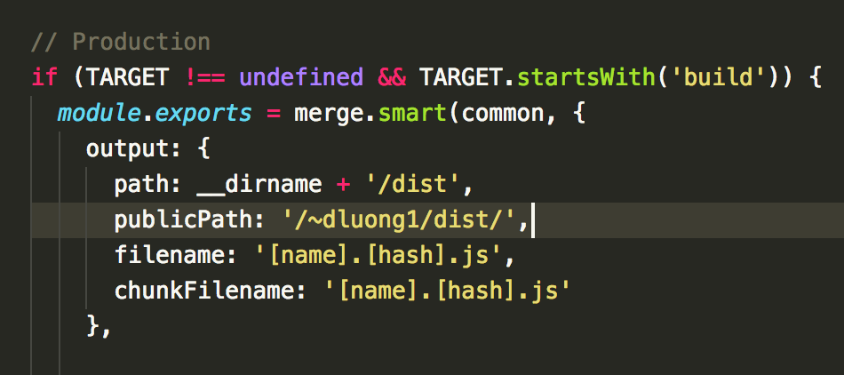

Webpack uses this file to deploy source code and map assets to the correct URL, change value of **publicPath** to the correct sub-path. This file is in the root folder of the source code.

**4. app.services.js**

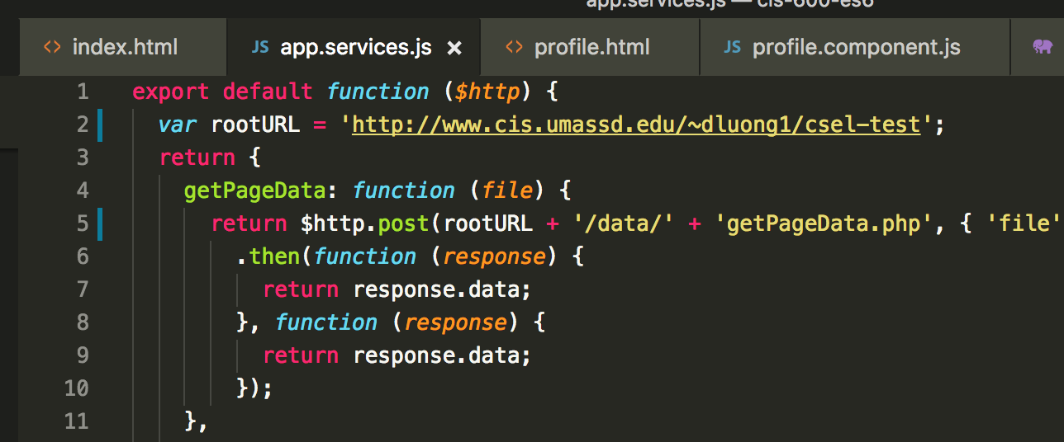

You can find this file under **src/app** directory. This file is the central place for reusable services which many components in the web application use, please change the value of **rootURL** to the appropriate value of the root directory of the source code.

**5. profile.component.js**

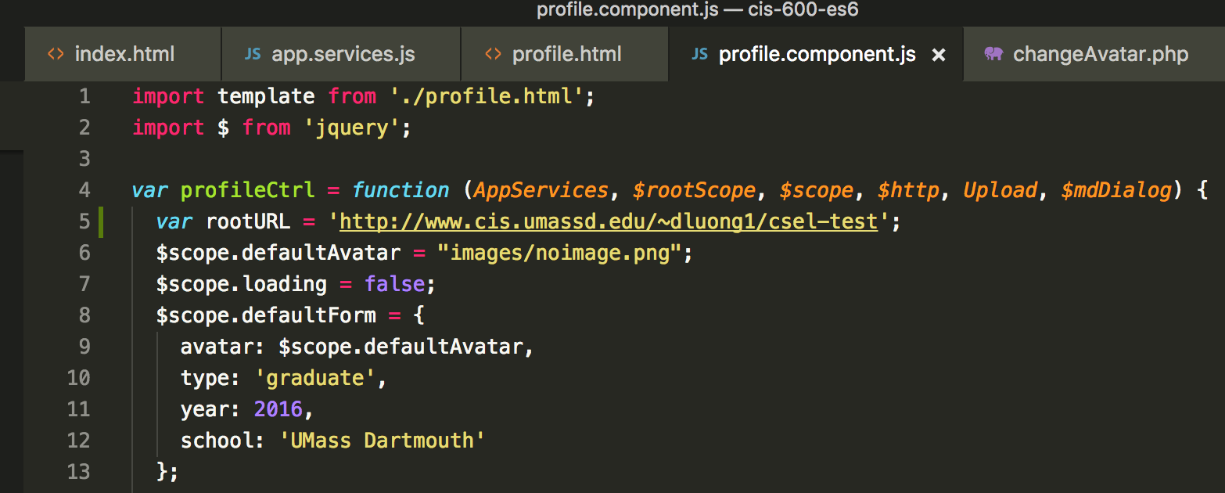

You can find this file under **src/app/profile** directory. Please change the value of **rootURL** to the appropriate value of the root directory of the source code.

# Deployment

To deploy project, you can run ‘**npm run build’** or **‘yarn run build’**, when finishing compilation, the project is available at **/dist** folder, you can upload all the content of this to server.

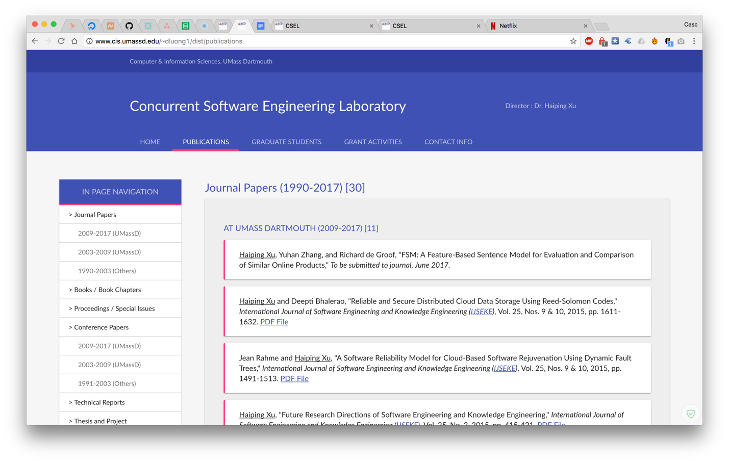

If the server does not support PHP, then you need to disable PHP features:

**1. Disable HTML markups in index.html**

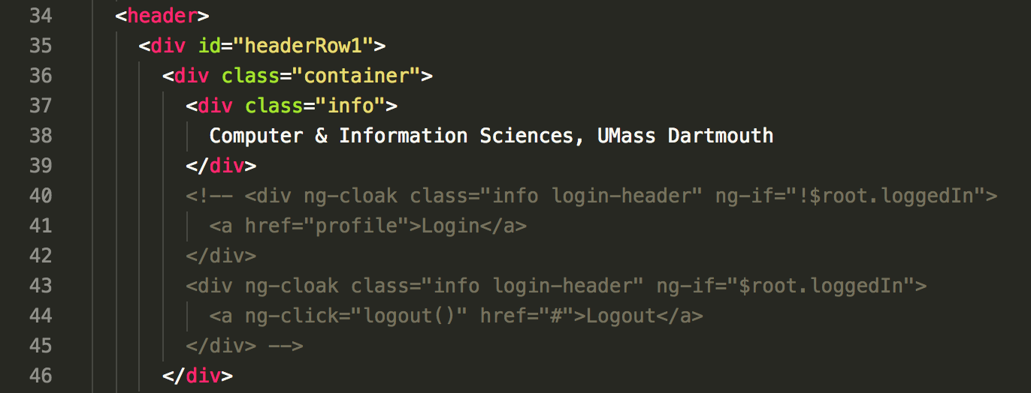

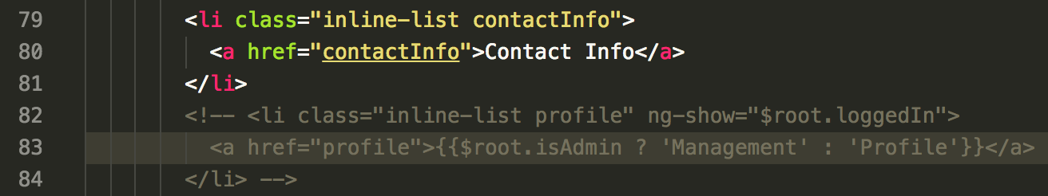

Please comment code from line 40 to line 45, and from line 82 to line 84.

**2. Disable Profile functionalities in app.js**

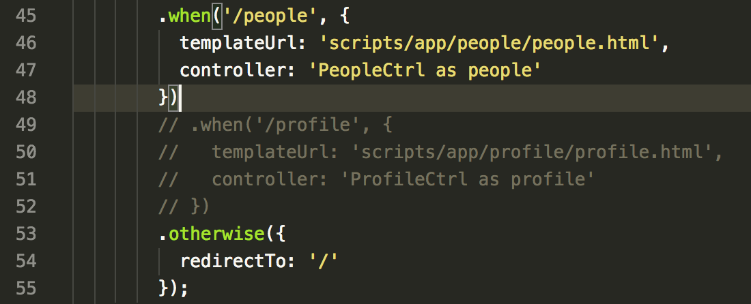

Please comment code from line 49 to line 52.

# Replacing Non-Compile Version Libraries with The Compiled File

If you would like to replace all the libraries reference in the non-compile version with one single vendor.js file from compiled version, please follow these steps:

1. Compile the compiling version

2. Copy the vendor.js from dist/scripts/lib of compiling version to scripts/lib of non-compile

3. Edit the index.html in the non-compile to reference to this file

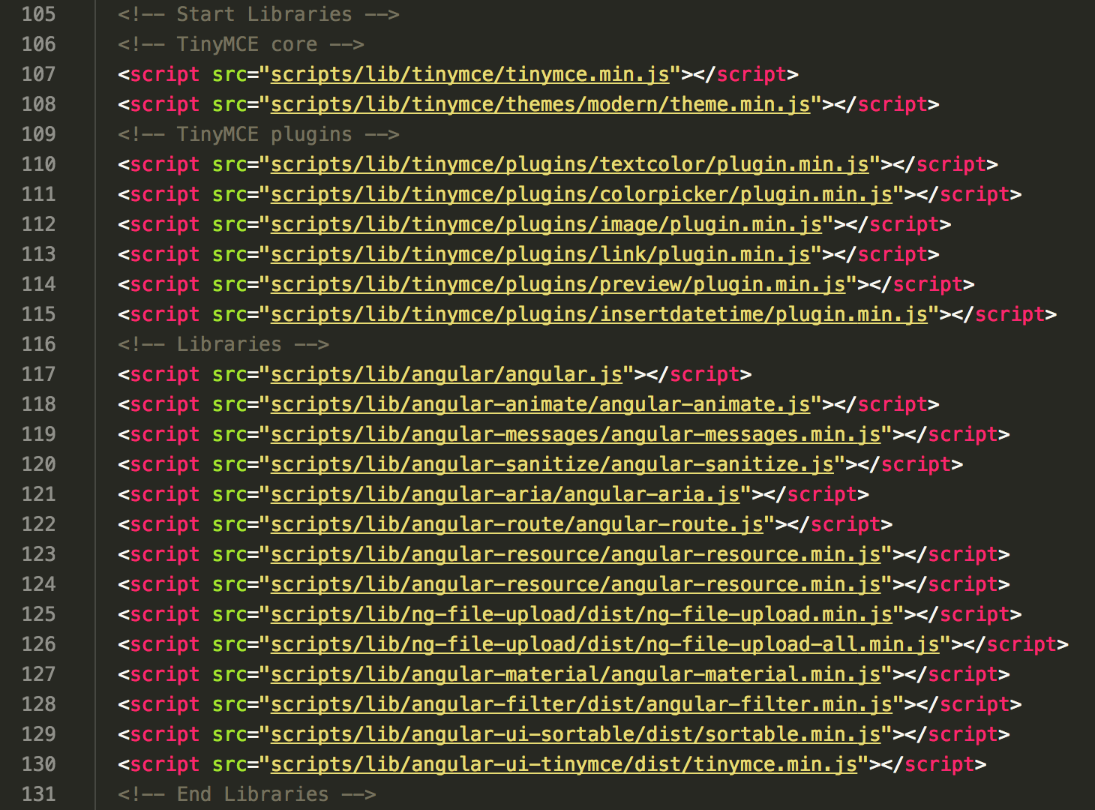

Please replace all the libraries reference from line 105 to line 131 with only one reference to vendor.js

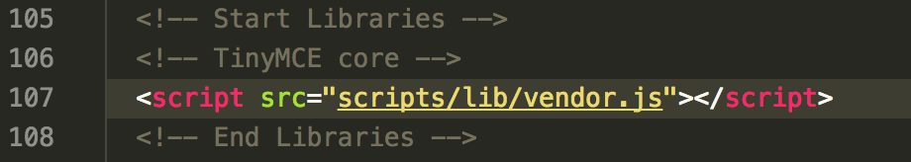

# Reference

<http://blog.teamtreehouse.com/install-node-js-npm-windows>

<https://ruleoftech.com/2015/setting-up-bower-and-gulp-in-windows>

<https://github.com/gruntjs/grunt-contrib-sass/issues/222>

<http://www.tutorialspoint.com/ruby/ruby_installation_windows.htm>

<https://www.npmjs.com/package/generator-webpack-angular>

<https://github.com/angular-ui/ui-router/wiki/Frequently-Asked-Questions#how-to-configure-your-server-to-work-with-html5mode>

<https://ngmilk.rocks/2015/03/09/angularjs-html5-mode-or-pretty-urls-on-apache-using-htaccess/>

<https://teropa.info/blog/2015/10/18/refactoring-angular-apps-to-components.html>